Preeti Gajdhane

B L O G G E R | W E B D E S I G N E R | C A M P U S M A N A G E R

# ABOUT ME

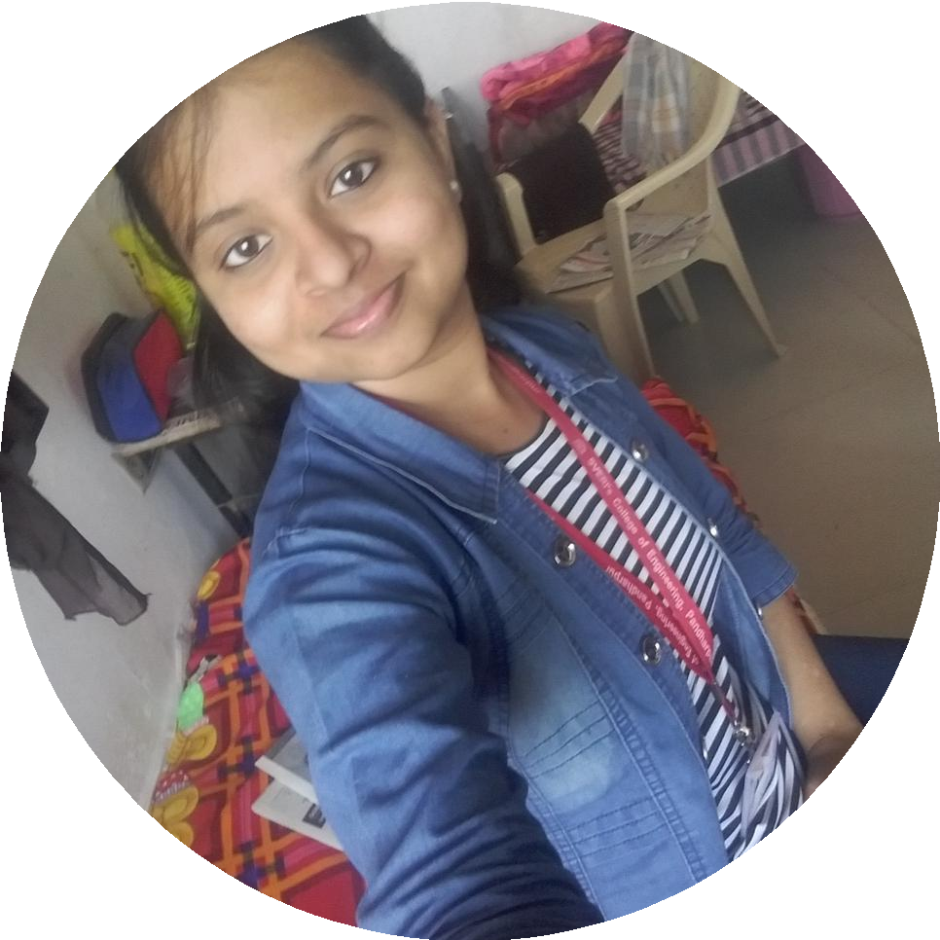

I am a Blogger and Web Designer. I am working as a "Campus

Manager" Intern at Perfectskills and "Graphic designer" intern at Xpert. I'm pursuing Bachelor degree from computer science and Engineering

.

# MY EXPERTISE

1) website Design 2)Graphic Design 3)video Editing. 4)Data Entry. 5)Blogging.

6) Digital Marketing. 7)Animation.

1. Logo Making. 9)freelancing. 10)Leadership. 11)Teamwork.

# HOW TO CONTAC ME

Address: Netke Plot, Alipur Road,Barshi

.District:solapur,State:Maharahtra, Country:India

Email: [preetgajdhane6@gmail.com](mailto:preetgajdhane6@gmail.com) Website:https://preetiblogm.blogsp ot.com/

Linkedin profile:https://[www.linkedin.com/in/](http://www.linkedin.com/in/) preeti-gajdhane-2a97541aa/

# PROJECTS WORKING ON

*Online farm equipment availability and sharing system*

This is one of the project I am working on. My aim is to develop an application for farmers. Documentation of this project is completed.

*Engineering college automation and Schedulling*

This my final year project I am working on this project . This project is for college management.

**Internship**

* 1. I have completed Internship at Microsoft.
  2. I am doing internship at Perfectskills.
  3. I have completed Internship at Intech Olympaid, with project title" online farm equipment availability and sharing system"

SCHOOL BACKGROUND

## Solapur Univercity

*pursing-Btech(computer science and engineering)*

-completed second year with 7 CGPA

## pune Board

*completed 10 from pune board completed 12th from pune boad*

* secured 88.60% Grades in SSC.
* secured 66.70% Grades in HSC.